Crffi16i(&.q-)
ffi
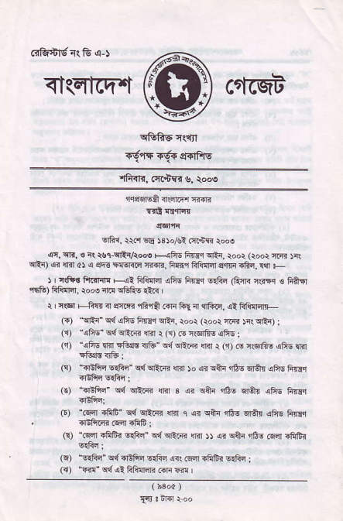
<t(Elfi't ctfrqi
^{qftAE} crct
TelfT6.re|{Av
^{'lffiR,} cit'bsd s, rooe
'r.icsMi ^{qlsiiqr} F{]i
T'! rnqfir
{6t Fl
!rFr, r{r sE )3 )ol* cft.irr rooa
(4 ^{qrr,} 6 it _{rslqlrAod HEs Ftrir} ^{qt1} ioor (root ^{nifij )r( qtr)} {n _{{Ft al} ^{q} _{sn-} ^{qEf{(c} rfiRr, F$r FiiI] s.tr{.fiq,!{1ts ) | ntF. frFrr, <l ^{{l!m .es tric @d{"} rfrm 'l *l € t'ftr Tifq) FFfllr. ro@ irir cEfti {er{ |
r I n€l F _{:A{, n} ^{qrlrr qn€} 4n _{liq rl} llltuq, ^{q!} Fii{qtr- _{({)} ^{t{rtr"} _{c{} ^{qfts} _{firm} ^{q'ta,} rdoi _{(roor} ^{qFrq} )i| ^{!ntr)} ; _{(i)} ^{'qfis'} q{qrlnn ^{qrfi} r (9 _{N iglfr6} ^{qfrE} ;
⁽¹ "qfis _{rir} ^{tFE{.s} _{r]fr"} ^{q{ qEt{r} {rit _{t} (n) _{G rsfi6} ^{qfis l]il} rtuc4ft: _{(!)} ^{.+isfifr} _{EqFn"} ^{q{ qrtid} {lil )o o? car n6q srtu {F6 FFic ?EAq ^{lt$n} ;
_{(€)} ^{_dtFn'} q{ ^{qt} _{ir} ^{qRr} _{s} ^{qr qfli} r6e _{s$r} ^{(fr6} Fi{d.r ₍₆₎ ^{_.Fr} .frIi" c{ cI!.{{ {Irr ₁ q" q&i ^{,rfiq} fiAn dis firdr , diFr.nn rsi {fib;
(!) "fq{n !frfi? _{6.fiq"} q{ ^{qA{{} _{$.r ))} ^{q? qai.J6s} .qa !ftGj
_{{6)} "sSa" c{EEtu srFq a{ cqsi.ftFr ^{6{frq} I
(r) _{"rr{"} ^{q{.fi} Flillnl< ..lr @ I
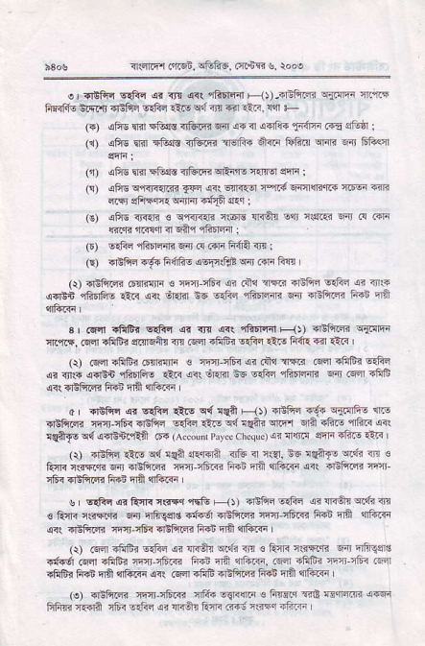
i]{nri{r.iisn, sf!&5, ariBri s. rod
e I ntF! E6c 6 ir{ .{<( rRdlr{l _{Ht-4lifi.4} ^{q{Irir} il.r15 FpRFfs i.51r {Btu @&i ias _{Ed3n} ^{ql} 1t _{r.} ^{llll} F
(F) ^{qh!} {ir ali{d 3ituif.6ir .!{ n colii t{{ii i-€ etur I lrr afr$ {rir F1ir. r]turFr alqfr4 A..r _{lift!} ^{qffr} lirl Fr*qr
_{rn) aFis im FRt€} ?n&rq? rflF.F ^{qn{€r qnr} I
(!),4Fr'6 cfil1{|{tri _{Fq,ci(} dr{tq fir{Fnlri{r. {6vl riR _{4F' sftFf4{} ^{qifi} {qa ^{!r.{} i
r€) ,eFE T{6n € ^{q,firr4{F} _{r.FRt !n+{} ^{qrt} c$rr{i 4ir .{ c+I. ^{lf{dq 'tFF.n} _{{ €aq} ^{qfiDrair} :
_{O)} ^{s$s} _{"iliI]{ir. m} (:I (ar F6a {r 1
€ aEfrs sf{ _{fi{h€} ^{qoli$E qir} cn Fq I
^{(r)} {IifrFr .6{R!r1i € *ir rfi{ ,4< ciq iif.i dElis 6:fir .1i nnr ^{q.lbn} _{rffi! €.r} ^{qr} 6.Rr n6 elF,l rhtr.ffi Fr _{{trftqa F@t} qri
s I cqi affFr 661 4r rrl _{{(} ^{'ifirFfir} F--{t _{?EF.n} q4!lF _{rn'f.r.} ^{(Fqr} .fitrd sr{rsih rlT rFr -fi&< ssc tsr Fll{ €ir rir< | ^{(r)} cF.r -frtr< 6rrrfir s cq?t-fi ai riqlsr< !q:n rfiEi Efiq ,!? _{sn$ 4Tl6n rfin$is ia.r} ^{qir} it{ri EE _{6Ss} ^{qffIrriR} sn Gfl rftF ^{qr! qEfrir.} _{frd na} qii.F
o rsft r _{6dlr ltE} ^{q4} _{lAn F1t} q+6 .6d ri.q$, m ^{qifrr.?} fti.ri'r f!'F !rf.F rt0, nd n{n qiFr sn .@ f;R i{! _{{qiiJq} ^{q{} airinr,li$ {t{ (A€oh, Pxye cheque) << {!tin sq-la .E E 1lr{ |
(r) dnfi! _{i!!!} ^{q{} !q? $<ffia 4tu sr _{r.{r,65 lqftt-} ^{q{.4{} € Eft rffi n rriFirq ffiift< FRi trff $'frr<a ^{q<{} .Efi.4 n-r] _{cF< dtFd< Flr!} qla qft..a
s v{ar 4 ftfi<{.+t'i5& Flt _{sEfiss.fri} ^{qr} _{!f<qt} ^{q.di} rt s f+i3 csFJR 6r nF$rl€ _{#!sl dnft< niql ifilrr Fd nfr} qrft.F @q diftR rElr-fi _{cEfirdi R.n EA} qrtuT{
Q) clql.fifi< ESq or ^{:lr{St} crdr r'{ _{! ftnri n(.riqr} qir qfi\qls ndr6 Gia lFtri n{-q6r< FFb fl? !'6i<. .se afifri ffi nfrn Fa _{{S&{Fl{!nff} ^{q1tura<r} {Fr.nrF _{rrEFrq. Rs nnr} qitu<
_{(r 6iltiln} ]@.trb1R 'lga .{Fc € Fq$. rdo F -m !6F Frhr. @la ffii 6.1id a? rr{ft Fin .63 c'@ EtoF
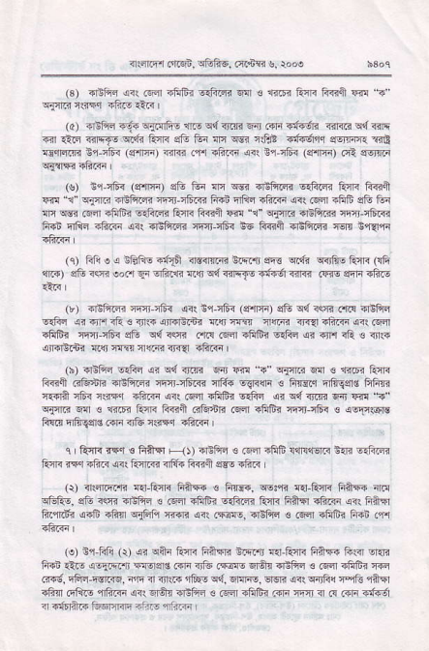
n(iiF r otsn, rr&F6. at+c '!, rooo
(3) ?reftr (i<.6i4 _{-frfr? s{ft4} ^{q{} € filB _{iirF friiEl} ^{qi!} ? ^{ql4r<} iift,r -frr €:<
_{(o)} ^{qdfti} {€{ ^{q{lrfi$} _{{F} ^{q{} _{<rm} ^{q4J} _{.{]i 5ft6r< {iriE} ^{qd} <E {ir A-rE _{&]Fto} ^{qdi} _{E.nlr} ^{qft} Gi fi w cSE aturr.i er'rrarq {r& Edlil4rm Eq-q6< (En{r) _{.ir< .,r'r 4ftF} ^{q(} i1,c6{ (!ffF) .4i sreirr{
_{{s)} n4l6< (EfrF) sG tui flc @ FBlirq 6rftn frtR l?iiqr _{Fd} ^{-r" qi{.?} -EftR nrl]-n6R FRD n8s -ftr.r an (qa afiiF sG tur _{an} ^{qdn} fsfl 4Fm4 eSr4 AqR _{ft€fl @ \"} ^{qflri} arBFrn il'-nFr{r frd Efta -h.<r ai! -Eft@ errfi< Ee ft€ft ddli.d {51n i,qir
(c) _{ftieqntrF4d1A ildffiRbFrr si3} ^{q{i qirtus} AIl< FF {lR) sF iw eor.l ql !rfi..li _{{q c{ {$'i{o +ffr {ir<} (w gqR.ft€
(r) _{{]3to4 e-Jit.} ^{q<r} i4ffi< (3{a) _{sG} ^{q4} 3s .,r.s 4liFlc s$i si -fi i& € _{]lr-} ^{qraE} n? {!riFR n@ ir4{.fiF <<r crsr _{afrE? nqnJ r6s sG W rrf{ !r.{} (qfl ^{qfrFr} _{@Sn} ^{qr qrn} iR ! d{+ ,4ndtrrni !i!r r@ ftrin r'{a rF..i I
(b) .liFn _{s:1ii} ^{q< q{} _{<rm En @ 5_} qFn< ^{qfl} € ftrrr furi _{ft€i trffiri dnfil<} ^{qir} rER ilffi 6{Rni ! FTdd nfigerd FFs {.+1A rf< {.-q _{+ftF} ^{qrt} Fdl sfrlir _{s.&n} ^{qiq{ti'RqnR} ?" q{rr. ^{q:|l} € {iIEi Qra F{jll G&+R i.Fn rfrtrq rrrfl ffi< _{c} qllr.sF
ftllr Ftuao.o. aa. ':tr dn6
^{q} R{i. rr.r s Rffa F1t ri!frr € .6cr ?fiF ll|rq€lrr $rl? !:filc tul< n,t ift< a<{ 1blr€ 3'tr{ F€fr lEE .ft?
(i) n.{riFrT< n{ turi liirF{ € _{FTr€, w:,n} ^{q{} Qcr< finF ft! ^{qf-ft-,} sG ffi diFq ts .6ra -Ftrr sfrqi _{ltaF fiffa1"ftlr} ^{qir} Ferir fii.'ni'j ,arE _{rk{l TiFli !3TE} ^{qrr.,Fir€,} EEftc s csfl ifrfri liin .+r
(e) n.r fri _{(r)} ^{q< qan} tori _{Fam iiqrr} ^{q{,AqF} F?F ts{ir -r{i F.d _{1l'-q} q61n ^{-r} _{F{srsls GF <r& i5@} ^{qlqn} .ltFn ! 6{l aFfr? @ F{6, n€iq-Fsr..q, rir a ift.. r&s qd, ^{qllre,} _{ErsTr a?l} ^{qirFc} _{r-i3} 'liFr _{<thrl .ttts 4ftri} ^{q( qlar} _{dBlid c} ^{(@r} -litr< .{F frrr ir ^{({} ioF d€6 I -6rft? Glurlrqq nin! daai
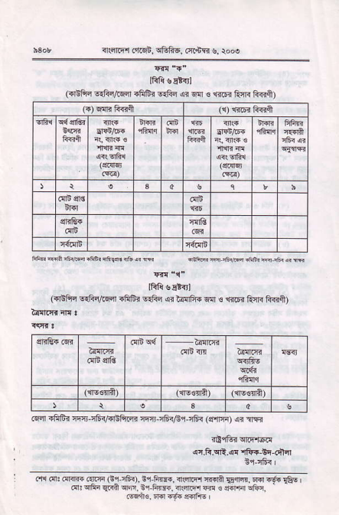
^{in€n} h'r .'r.d, sftfi_6, ^{(a..is} s, roN
^{qr{} 5-
lRfi s*{rl
(dE1i_{ s.frq,Gcn !fifis 6rFq @ e{i 6 fr6i Rrr{ F€i)
FFBFiii6{difrnar5r*{rF
m "i"
_{IFii} qlt{rt
({'EFq FSq,tsqt.fiffr EG.l ,4r _{hffir{} ^{qlr} € 116r ftir F?3i)
@ni iliBi eri-fi,@E ^{ir n'I n6{,6rifi<} _{{qfia)} ^{qi} ?Tr
<i,lBrq|F'Ed
q.F.qR.ar .lfrr_li-d:fl
nr,fi |
i fir d: ffi ar!r{ G,ii6i). !r,F r..dsiiErrrdns.liq,!l{|"6-.€s @ ^{q6"} _{{r{n} ^{qFF,} Er F@. ?lcrdr @ € _{cffi} q6n

